Estimation of Characteristic Impedance (Z ) and Propagation Constant (γ) o
of a Transmission Line from Primary Constants

Test Case 1
Investigate the significance of Characteristic Impedance (Z ) and Propagation Constant (γ) of a transmission o line using the following primary constants: a) Resistance, R = 10 Ω/km
- Capacitance, C = 8 µF/km
- Inductance, L = 3.5 mH/km
- Conductance, G = 4 µmho/km
- Frequency, f = 2 kHz

Scilab Program
clear; clc; R = 10; L = 3.5e-3; f = 2*10^3; G = 4*10^-6; C = 8*10^-6; w = 2*%pi*f; Z = R + (%i*w*L);
Y = G + (%i*w*C);
Zo = sqrt(Z/Y);
C1 = round(real(Zo)*1000)/1000; D1 = round(imag(Zo)*1000)/1000; printf('Zo = %f + j(%f) ohms\n', C1, D1);
P = sqrt(Z*Y); a = real(P); a1 = round(a*10000)/10000; printf('Attenuation constant a = %f neper/km\n', a1); b = imag(P); b1 = round(b*10000)/10000; printf('Phase constant b = %f radians/km', b1);
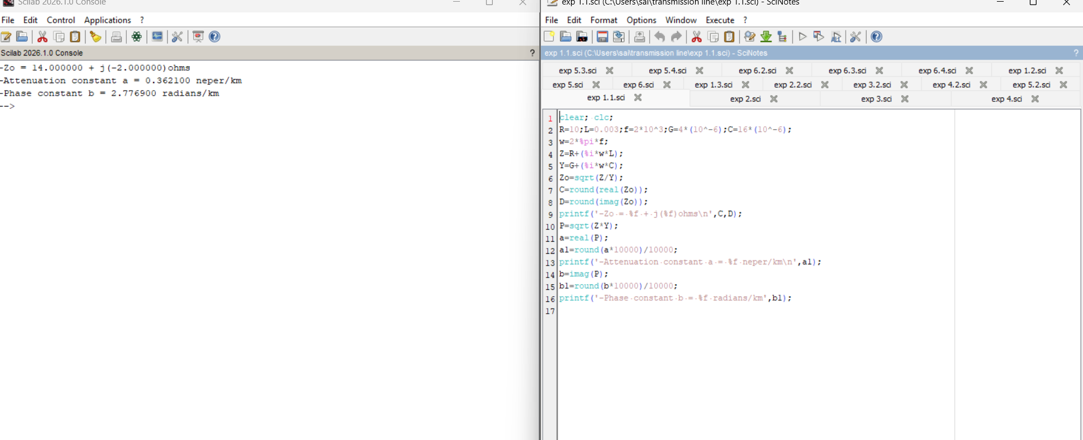

Result Table
S.No |  | Parameters | Simulation Results |  |  | Theoretical Results
 |  |  | Z■ (ohms) | α (Np/km) | β (rad/km) | α (Np/km) | β (rad/km)
 | 1 | R=10, L=3.5mH,  C=8µF, G=4µmho, f=2kHz | 21.050 − j2.362 | 0.2376 | 2.1161 | 0.2376 | 2.1161

Test Case 2
Examine the impact of resistance and inductance on Z and γ at f = 2.5 kHz. Vary R from 10 Ω to 50 Ω in steps o
of 10 Ω (L, G, C held constant); then vary L from 3.5 mH to 11.5 mH in steps of 2.5 mH (R, G, C held constant).

Scilab Program (update R or L per row and re-run)
clear; clc; R = 10; L = 3e-3; f = 2000; G = 0.4*10^-6; C = 8*10^-6; // set R (or L) per row w = 2*%pi*f; Z = R + (%i*w*L);
Y = G + (%i*w*C);
Zo = sqrt(Z/Y);
C1 = round(real(Zo)*1000)/1000; D1 = round(imag(Zo)*1000)/1000; printf('Zo = %f + j(%f) ohms\n', C1, D1);
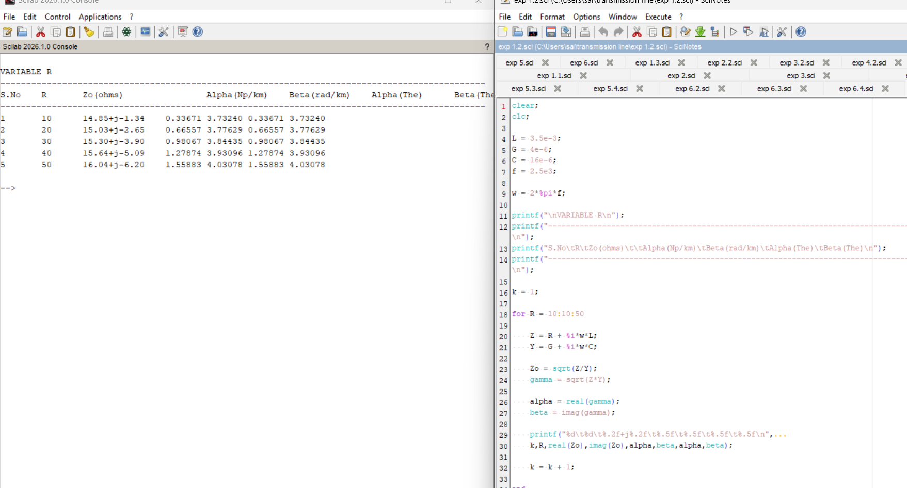
P = sqrt(Z*Y); a = real(P); a1 = round(a*10000)/10000; printf('Attenuation constant a = %f neper/km\n', a1); b = imag(P); b1 = round(b*10000)/10000; printf('Phase constant b = %f radians/km', b1);

Variable R (constants: L = 3 mH, f = 2000 Hz, G = 0.4×10⁻⁶, C = 8×10⁻⁶)
S.No | R (Ω) | Simulation Results |  |  | Theoretical Results
 |  | Z■ (ohms) | α (Np/km) | β (rad/km) | α (Np/km) | β (rad/km)
1 | 10 | 19.532 − j2.546 | 0.2560 | 1.9635 | 0.2560 | 1.9635
2 | 20 | 19.994 − j4.975 | 0.5002 | 2.0100 | 0.5002 | 2.0100
3 | 30 | 20.667 − j7.220 | 0.7258 | 2.0777 | 0.7258 | 2.0777
4 | 40 | 21.468 − j9.267 | 0.9316 | 2.1582 | 0.9316 | 2.1582
5 | 50 | 22.337 − j11.133 | 1.1192 | 2.2456 | 1.1192 | 2.2456

Variable L (constants: R = 10 Ω, f = 2000 Hz, G = 0.4×10⁻⁶, C = 8×10⁻⁶)
S.No | L (mH) | Simulation Results |  |  | Theoretical Results
 |  | Z■ (ohms) | α (Np/km) | β (rad/km) | α (Np/km) | β (rad/km)
1 | 3.5 | 21.050 − j2.363 | 0.2375 | 2.1161 | 0.2375 | 2.1161
2 | 6.0 | 27.446 − j1.812 | 0.1822 | 2.7592 | 0.1822 | 2.7592
3 | 8.5 | 32.632 − j1.524 | 0.1532 | 3.2805 | 0.1532 | 3.2805
4 | 11.0 | 37.105 − j1.340 | 0.1348 | 3.7302 | 0.1348 | 3.7302

Test Case 3
Explore the impact of frequency and capacitance on Z and γ. Vary f from 2 kHz to 10 kHz in steps of 2 kHz (L, o
R, G, C held constant); then vary C from 8 µF to 16 µF in steps of 2 µF (R, G, L held constant).

Scilab Program (update f or C per row and re-run)
clear; clc; R = 10; L = 3e-3; f = 2000; G = 0.4*10^-6; C = 8*10^-6; // set f (or C) per row w = 2*%pi*f; Z = R + (%i*w*L);
Y = G + (%i*w*C);
Zo = sqrt(Z/Y);
C1 = round(real(Zo)*1000)/1000; D1 = round(imag(Zo)*1000)/1000; printf('Zo = %f + j(%f) ohms\n', C1, D1);
P = sqrt(Z*Y); a = real(P); a1 = round(a*10000)/10000; printf('Attenuation constant a = %f neper/km\n', a1); b = imag(P); b1 = round(b*10000)/10000; printf('Phase constant b = %f radians/km', b1);
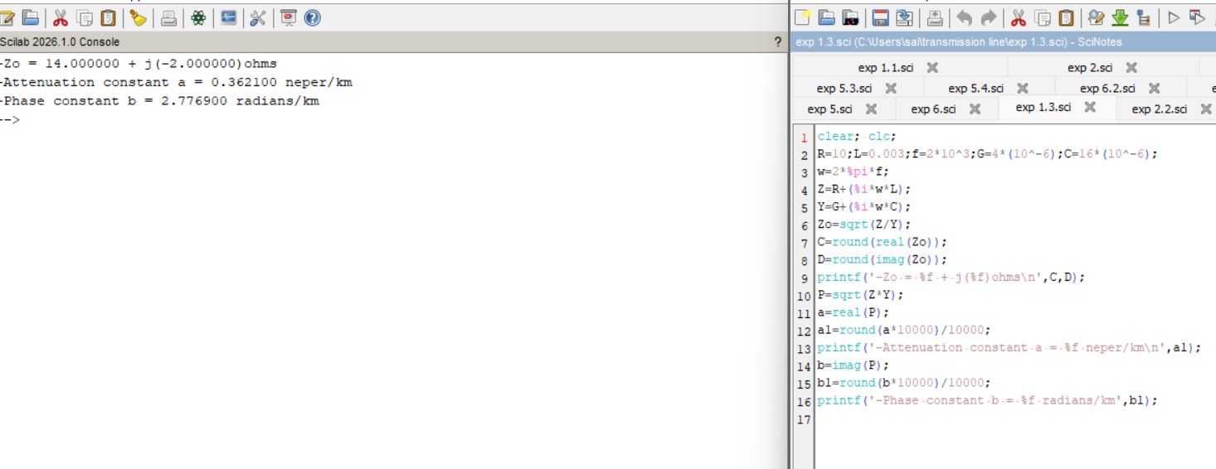

Variable f (constants: R = 10 Ω, L = 3 mH, G = 0.4×10⁻⁶, C = 8×10⁻⁶)
S.No | f (Hz) | Simulation Results |  |  | Theoretical Results
 |  | Z■ (ohms) | α (Np/km) | β (rad/km) | α (Np/km) | β (rad/km)
1 | 2000 | 19.532 − j2.546 | 0.2560 | 1.9635 | 0.2560 | 1.9635
2 | 4000 | 19.407 − j1.281 | 0.2576 | 3.9021 | 0.2576 | 3.9021
3 | 6000 | 19.384 − j0.855 | 0.2580 | 5.8460 | 0.2580 | 5.8460
4 | 8000 | 19.376 − j0.642 | 0.2581 | 7.7914 | 0.2581 | 7.7914
5 | 10000 | 19.372 − j0.513 | 0.2581 | 9.7373 | 0.2581 | 9.7373

Variable C (constants: R = 10 Ω, L = 9 mH, f = 2500 Hz, G = 0.4×10⁻⁶)
S.No | C (µF) | Simulation Results |  |  | Theoretical Results
 |  | Z■ (ohms) | α (Np/km) | β (rad/km) | α (Np/km) | β (rad/km)
1 | 8 | 33.562 − j1.185 | 0.1490 | 4.2175 | 0.1490 | 4.2175
2 | 10 | 30.019 − j1.060 | 0.1666 | 4.7153 | 0.1666 | 4.7153
3 | 12 | 27.403 − j0.968 | 0.1825 | 5.1654 | 0.1825 | 5.1654
4 | 14 | 25.370 − j0.896 | 0.1971 | 5.5793 | 0.1971 | 5.5793
5 | 16 | 23.732 − j0.838 | 0.2107 | 5.9645 | 0.2107 | 5.9645

Result

The characteristic impedance and propagation constant of the transmission line were estimated for varying R, L, f and C, and the simulation results (Scilab) were verified against the theoretical values calculated from Z = R + jωL and Y = G + jωC.

